Voyage vista: Illuminating Insights From Uber Expeditionary Analysis

**1**.**INTRODUCTION**

**1.1** **OVERVIEW**

Uber Technologies, commonly known as Uber, was a ride-sharing company and offers vehicles for hire, food delivery (Uber Eats), package delivery, couriers, freight transportation, and, through a partnership with Lime, electric bicycle and motorized scooter rental. It was founded in 2009 by Travis Kalanick and Garrett Camp, a successful technology entrepreneur. After selling his first start up to eBay, Camp decided to create a new start up to address San Francisco’s serious taxi problem.

Together, the pair developed the Uber app to help connect riders and local drivers. The service was initially launched in San Francisco and eventually expanded to Chicago in April 2012, proving to be a highly convenient great alternative to taxis and poorly-funded public transportation systems. Over time, Uber has since expanded into smaller communities and has become popular throughout the world. In December 2013, USA Today named Uber its tech company of the year.

In Supervised learning, we have a training set and a test set. The training and test set consists of a set of examples consisting of input and output vectors, and the goal of the supervised learning algorithm is to infer a function that maps the input vector to the output vector with minimal error. We applied machine learning algorithms to make a prediction of price in the Uber Dataset of Boston. Several features will be selected from 55 columns. Predictive analysis is a procedure that incorporates the use of computational methods to determine important and useful patterns in large data.

**1.2** **PURPOSE**

The objective is to first explore hidden or previously unknown information by applying exploratory data analysis on the data set and to know the effect of each field on price with every other field of the dataset. Then we apply different machine learning models to complete the analysis

**2.PROBLEM DEFINITION &DESIGN THINKING**

**2.1 EMPATHY MAP**

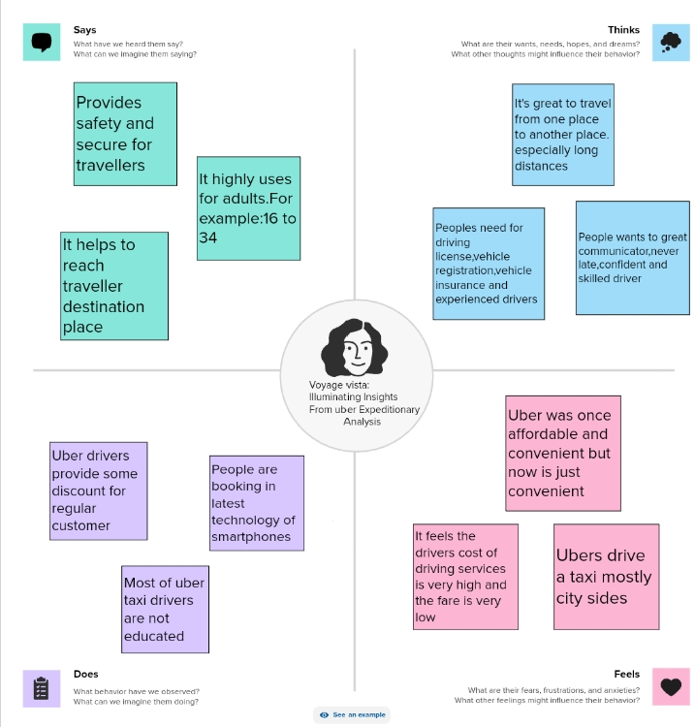

**2.2.IDEATION & BRAINSTORMING MAP**

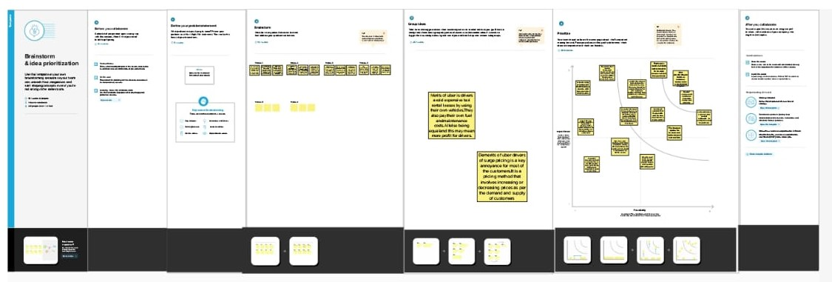

**RESULT**

**DASHBOARD1**

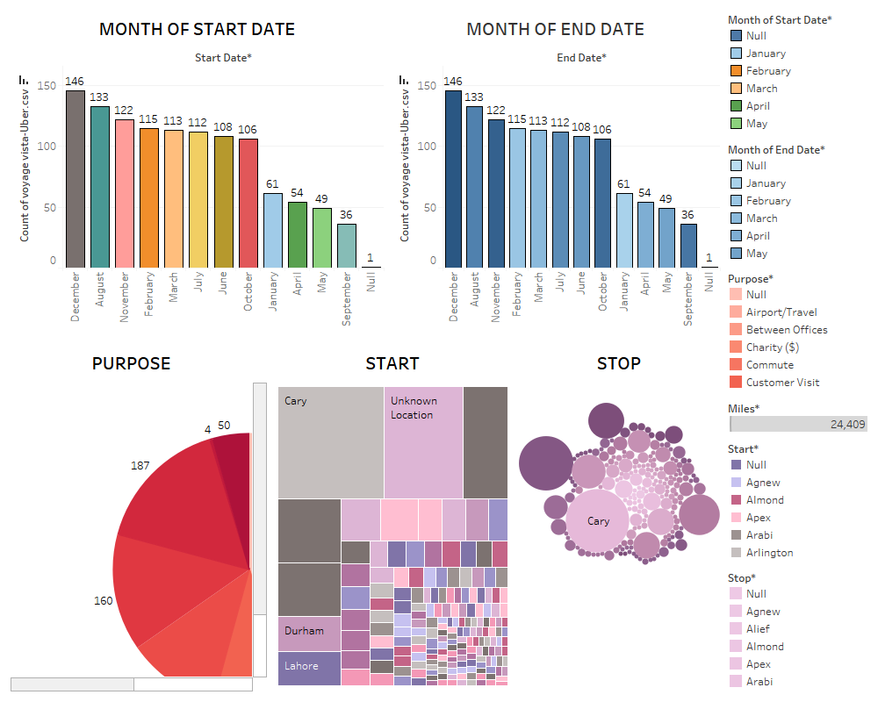

**DASHBOARD2** 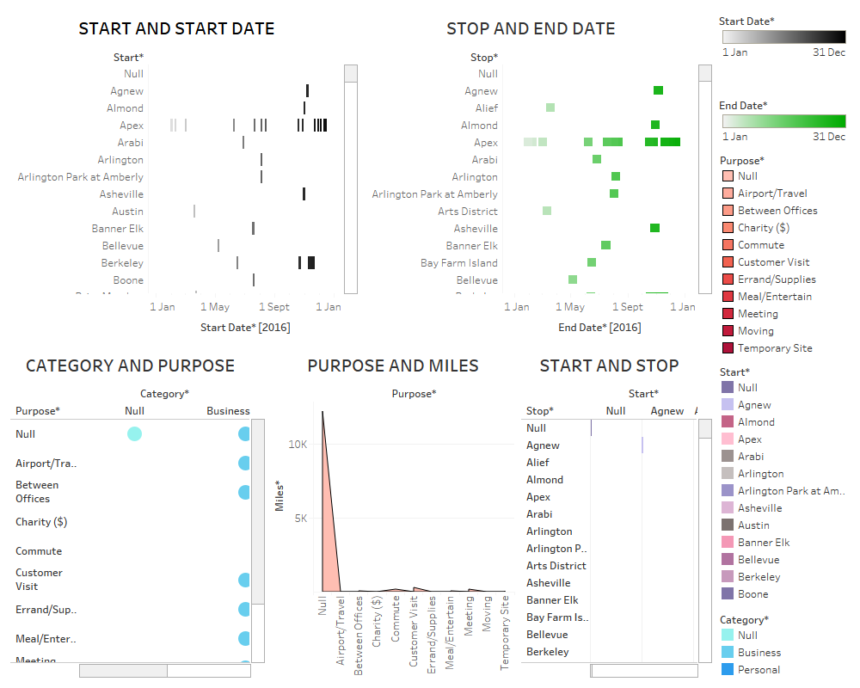

**DASHBOARD 3**

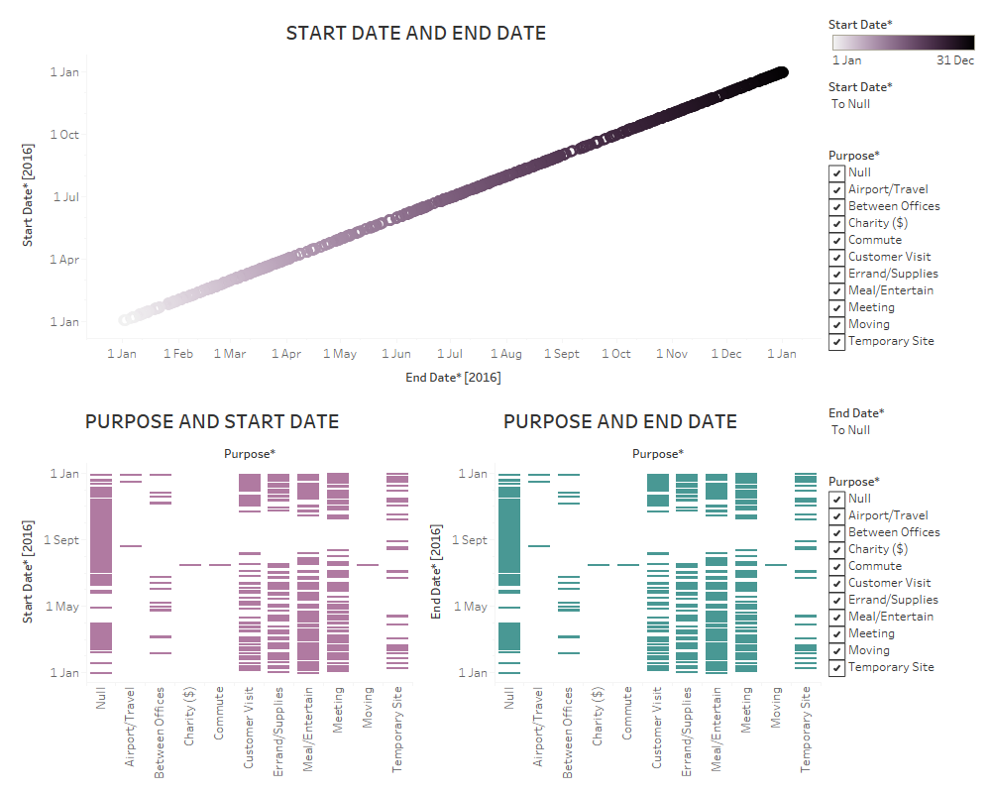

**STORY 1**

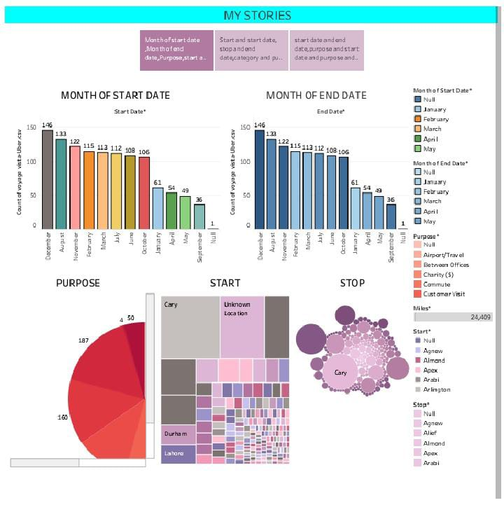

**STORY 2**

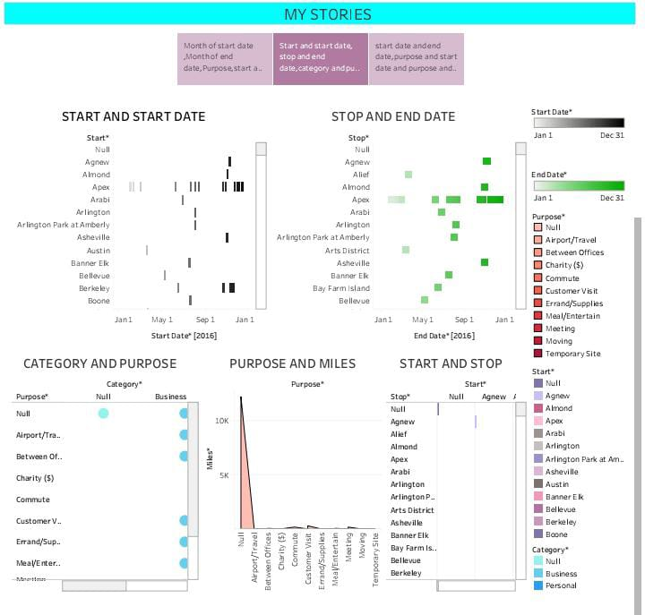

**STORY 3**

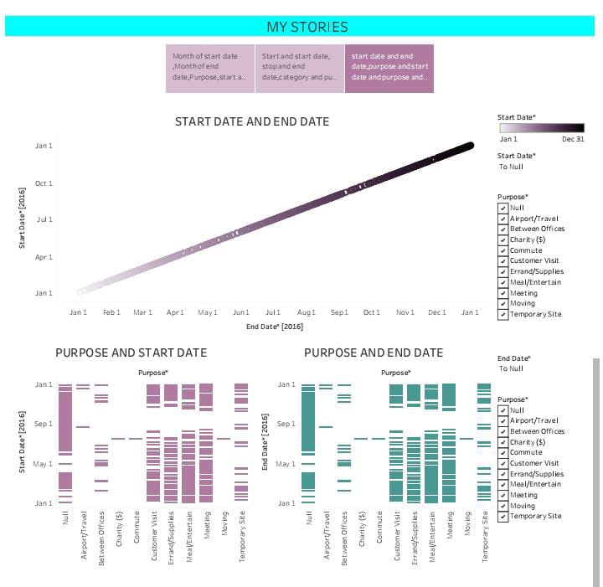

**ADVANTAGES**

* While wait times vary, Uber customers typically spend far less time waiting than customers of traditional taxi services. Riders also have the option to share riders with others heading in the same direction through Uber pool, the app’s ride-sharing feature.
* Uber always show you the estimated fare before starting the ride.
* Safety is the one of the major benefits of riding in uber.
* Passengers credit or debit card is linked to the taxi app account, no cash changes hands.

**DISADVANTAGES**

* The need to maintain a vehicle that meets Uber’s standards.
* Expanses for gas, maintenance and insurance.
* Increased competition among driver.
* The possibility of receiving negative reviews.
* Uncertainly about the payment rate for each ride.

**APPLICATIONS**

* Uber links passengers with drivers using the uber app. Generally, the drivers own their own car. The company does also offer rental or lease on cars through third party partners like hertz, Get around and fair. Uber Fleet is an app for those managing squads of drivers.

**UBER’S VALUE PROPOSITION**

**FOR RIDERS FOR DRIVERS**

**\***Safety and security **\***Ease to get started

**\***Ease of booking **\***Opportunity to earn

**\***Easy & convenient Tractions **\***Freedom to choose working hours

**CONCLUSION**

Explanatory data analysis is no small feat! It takes a lot of work and patience, but it is certainly a powerful tool if used property in the context of your business. Uber is very economical; however, Lyft also offers fair competition. people prefers to have a shared ride in the middle of the night.

**FUTURE SCOPE**

The current world is witnessing many advancements and a lot of startups are evolving rigorously in the world for past few years. All because of the emergence of on-demand ideas in the current business world with a lot of opportunities. The on-demand apps assist you to order or book anything from anywhere.